Supplemental Materials

To accompany

Voluntary engagement with negatively valenced stimuli from childhood to early adulthood

Contents
- Supplemental Figure 1. Age distribution of sample
- Affective choice assessment instructions
- IAPS image valence and arousal ratings and counterbalancing procedure
- Supplemental Table 1. Comparisons of counterbalanced stimulus lists.
- Comparison of IAPS image subjective valence and arousal ratings in a separate sample of children, adolescents, and adults
- Supplemental analysis of youngest children’s choice behavior
- Supplemental analysis of image content
  - Social vs. Non-Social
  - Animals vs. No Animals
  - Descriptive Item-Level Analysis
- Supplemental analysis of reaction time data
- Supplemental Figure 1. Age distribution of sample
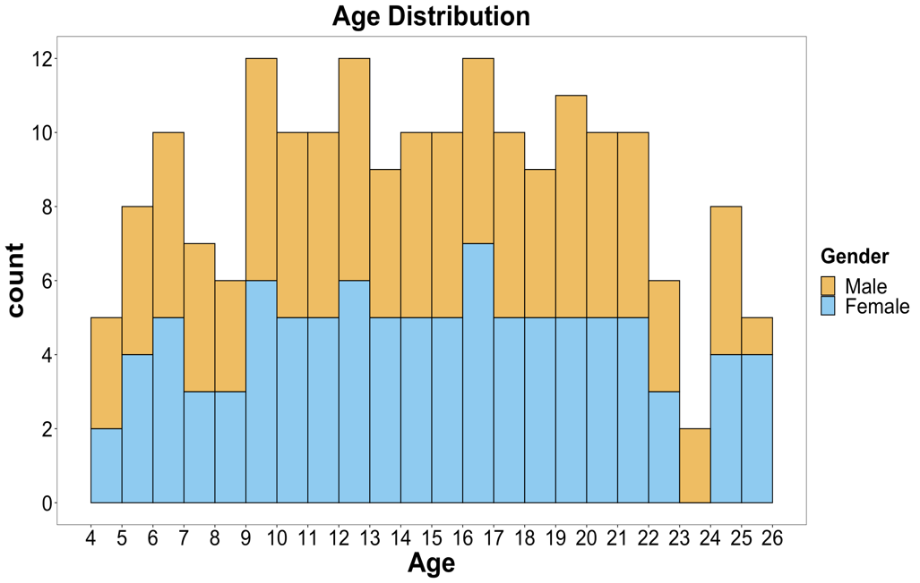
Figure S1. Distribution of ages across the sample. Each histogram bin represents one age year. Orange bars reflect the number of male participants in each age year and blue bars reflect the number of female participants in each age year.

- Affective choice assessment instructions
Welcome to the Picture Choices Game!
In this game, you get to make choices about what pictures you want to look at.
First, you'll see two small pictures for a short amount of time. You get to decide which picture you want to see again for a longer amount of time. Use the left key (the letter a) to choose the picture on the left and the right key (the letter l) to choose the picture on the right.
Once you pick a picture, you can look at it again for a longer time. When you're done looking at the picture and are ready to pick the next one, press space!
If you wait long enough, the game will continue on its own, but you can also use the space bar to move to the next set of pictures whenever you're ready.
Let's try some together!
Great! Do you have any questions before we begin? You will play this game in two blocks. Let the experimenter know when you're done with the first block.
Great! You have finished the first block. Please tell the experimenter.
Great! You have finished this game. Please tell the experimenter.
- IAPS image valence and arousal ratings and counterbalancing procedure
We used the normative IAPS ratings (Lang, Bradley & Cuthbert, 2008) to create image sets for the positive, negative, and neutral categories. Normative IAPS valence ratings were on a scale of 1-9, with 1 being more negative and 9 being more positive, and normative arousal ratings were on a scale of 1-9, with 1 being low arousal and 9 being high arousal. The selected positive images had valence ratings between 6.32 and 8.34 (mean = 7.24, SD = 0.46) and arousal ratings between 3.28 and 6.68 (mean = 5.15, SD = 0.74). Selected neutral images had valence ratings between 4.49 and 6.17 (mean = 5.09, SD = 0.32) and arousal ratings between 2.42 and 4.20 (mean = 3.15, SD = 0.50). Selected negative images had valence ratings between 1.79 and 3.85 (mean = 2.87, SD = 0.54) and arousal ratings between 3.67 and 6.87 (mean = 5.34, SD = 0.77).
Counterbalancing was used to ensure that participants’ tendency to choose one valence of images in a condition could not be explained by the specific images shown in that condition. Counterbalancing was achieved by first splitting the images in each valence category into “social” images (defined as images including at least one person) and “non-social” images (defined as images without people). The consideration of social vs. non-social was accounted for in the study design, and images were originally selected such that each valence category included 50% social images and 50% non-social images. Splitting the images in this way results in six groups of 20 images (positive social, positive non-social, neutral social, neutral non-social, negative social, negative non-social). Then these six groups of images were each split into lists “a” and “b” (e.g. positive social “a”, positive social “b”, etc.), with “a” and “b” lists within each valence balanced on normative IAPS ratings of valence and arousal (see Table S1 for counterbalancing statistics). Image list assignment was counterbalanced across participants such that image sub-lists “a” and “b” were assigned to the three choice types (negative vs. neutral, negative vs. positive, positive vs. neutral) at equal frequency. For example, one half of participants saw negative list “a” in the negative vs. positive trials and negative list “b” in the negative vs. neutral trials, and half saw these lists reversed. All potential assignments of the two image lists across three valence types produced 8 counterbalancing assignments, and counterbalance assignment was balanced further with respect to participant age and sex. In addition, each counterbalanced assignment contained half social images (i.e. images with at least one person shown) and half non-social images (i.e. images with no people shown). Therefore, the negative, neutral and positive image categories each contained the same number of social vs. non-social images.

- Supplemental Table 1. Comparisons of counterbalanced stimulus lists.

Table S1: Comparisons of counterbalanced stimulus lists.
 | Valence |  |  | Arousal
 | t statistic | df | p-value | t statistic | df | p-value
Negative list “a” vs. Negative list “b” | 0.282 | 38 | .779 | 0.406 | 38 | .687
Positive list “a” vs. Positive list “b” | -1.043 | 38 | .304 | 0.432 | 38 | .669
Neutral list “a” vs. Neutral list “b” | -0.043 | 38 | .965 | 0.369 | 38 | .715

- Comparison of IAPS image subjective valence and arousal ratings in a separate sample of children, adolescents, and adults
Due to time limitations, we did not collect subjective ratings of valence and arousal on the images used in the present study. However, we obtained rating data on a similar set of IAPS images in a separate developmental sample (unpublished data). Twenty-five of the 48 images in this separate sample were also used in the present study. The data in question included N=125 healthy individuals from age 9-23 who completed a separate experiment conducted at Harvard University in 2012-2013. These individuals provided subjective valence and arousal ratings of a similar set of IAPS images on a computer. Here, we queried those data to assess the degree of correspondence between children’s and adolescents’ subjective valence and arousal ratings of a similar set of images. For this supplementary analysis subjective valence refers to numeric participant ratings whereas valence refers to the image category of negative, neutral or positive. We conducted two mixed-effects linear regression models with subjective valence and arousal ratings as dependent variables and age, valence, and their interaction as predictors. For both subjective valence and arousal, we found no significant main effect of age (subjective valence: F(1, 118) = .07, p = .80; subjective arousal: F(1, 118) = 3.31, p = .07) and no significant interaction between age and valence (subjective valence: F(2, 236) = 1.46, p = .23; subjective arousal: F(2, 236) = .61, p = .54). We repeated these analyses for the subset of twenty-five images that overlap between the previous and current study. Similar to the results for the whole image set, for both subjective valence and arousal, we found no significant main effect of age (subjective valence: F(1, 118) = 0.27, p = .61; subjective arousal: F(1, 118) = 3.07, p = .08) and no significant interaction between age and valence (subjective valence: F(2, 236) = 1.34, p = .26; subjective arousal: F(2, 236) = 0.26, p = .77).
These results suggest that subjective valence and arousal of the images do not differ significantly across age for positive and negative images. These findings build confidence that in general, younger individuals experience these images with similar levels of valence and arousal as adults, thereby increasing confidence that our assignment of images to ‘positive’, ‘negative’, and ‘neutral’ categories was valid in the present study.

- Supplemental analysis of youngest children’s choice behavior
To ensure that the young children tested understood the task, we conducted a supplementary analysis on the youngest children in the sample (ages 4-6) to determine if they were choosing images at chance (i.e. 50/50) for each trial type. For the negative vs. positive trials, these young children chose negative images for 35.6% of trials, on average. For positive vs. neutral trials, they chose positive images for 73.9% of trials, and for negative vs. neutral trials, they chose negative images for 55.4% of trials. We conducted one-sample t-tests to evaluate whether these percentages differed from 50%. While young children chose negative and neutral images approximately the same amount (t(22) = 1.50, p = .15), their choice behavior for negative vs. positive trials (t(22) = -3.94, p < .001) and positive vs. neutral trials (t(22) = 8.11, p < .001) significantly differed from 50%. These results build confidence that even the youngest participants understood the task instructions, as their behavior indicates that they clearly differentiated positive images from neutral and negative images and chose to interact with positive images over other types of images.

- Supplemental analysis of image content
In order to explore the observed trend that younger children chose negative images more than older participants, we conducted a detailed analysis of the content of the negative images.
a. Social vs. Non-Social
First, we examined the observed trend in social and non-social images, as Oosterwijk (2017) showed evidence that this social vs. non-social difference in image content affects choice behavior in adults. In the present study, social images were defined as images with at least one person and non-social images were defined as images without people. Our study design structured social and non-social images such that each image valence category (positive, negative, and neutral images) contained 50% social images and 50% non-social images, and images were counterbalanced as described in Section 3 of the Supplemental Materials above. Importantly, each trial was designated as either social or non-social, resulting in a choice between either two social images or two non-social images. Therefore, there were no trials in which participants chose between a social and non-social image. Within the social images, there was also an equal number of images depicting close-ups of faces (as compared to images depicting people more distant) across valence conditions.
Overall, participants chose to view non-social negative images in 17.6% of trials for which a negative image was an option and chose to view social negative images in 17.7% of trials for which a negative image was an option. This difference was not significant (t(191) = -0.19, p = .85). The tendency to choose negative images decreased across age in non-social trials but not in social trials (see Figure S2). By contrast, behavior for the non-social trials were similar to the results reported for all trials combined; we found a significant interaction between age and valence (F(3, 379) = 11.79, p < .001) and choice for negative images negatively correlated with age (r(190) = -.26, p < .001). However, for social trials, we did not find an interaction between age and valence (F(3, 379) = 1.45, p = .23) and choice for negative images was not correlated with age (r(190) = -.09, p = .23).
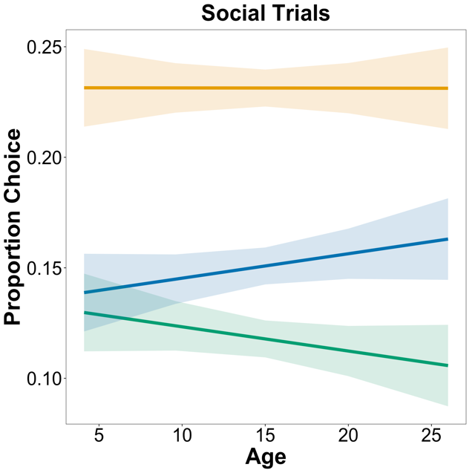
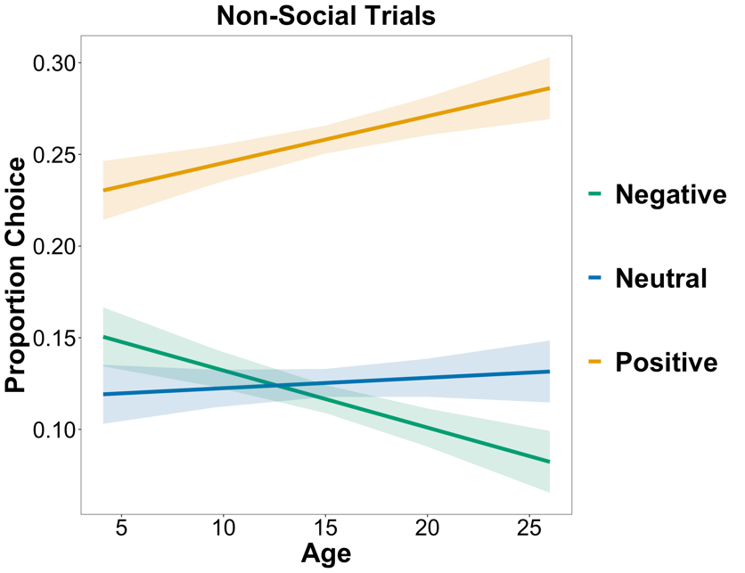
Figure S2. Proportion of trials that positive (gold), neutral (blue), and negative (green) images were chosen across age in social stimuli (left) and non-social stimuli (right). Proportions reflect overall choice of positive, neutral or negative images, collapsed across condition. Proportion choice is out of the total number of trials. Solid colored lines depict linear model fits. Shaded regions depict standard errors.

This result did not align with Oosterwijk’s (2017) finding that social negative images were chosen more often than other non-social image categories. However, there were differences in the participant sample and methods that we speculate may account for these different results. For example, in addition to the primary difference of age (adult vs. developmental sample), the two studies differed in their definition of “social”. Oosterwijk categorized images that display multiple people and emphasize interpersonal interaction as “social” (whereas single people or bodies were assigned to different negative categories), while the present study categorized images with one person or more to be “social”. An additional important distinction between the studies is that unlike in Oosterwijk (2017), we did not pit social and non-social images against each other.
To explore this surprising result further, we conducted a secondary supplemental analysis to determine whether children were especially drawn to non-social images featuring animals.

b. Animals vs. No Animals
We speculated that children may be drawn to images of animals, as research shows that early in development children show an attentional bias for threatening stimuli such as snakes and spiders (e.g. LoBue & Rakison, 2013; LoBue, Rakison, DeLoache, 2010). In our study, forty positive images and forty negative images were used, and of these, seven (17.5%) positive images depicted animals and six (15%) negative images depicted animals. On average across all participants, when an image of an animal (either positively or negatively valenced) was an option in a trial, it was chosen in 61.7% of trials. No neutral images depicted animals, and therefore trials where neutral images were chosen were eliminated from this supplemental analysis.
The tendency to choose negative images decreased with increasing age in both trials with animals and those without animals (see Figure S3). Similar to the results reported for all trials combined, we found a significant interaction between age and valence for animals (F(2, 189) = 9.12, p < .001) and non-animals (F(2, 189) = 4.63, p = .01) and choice for negative images negatively correlated with age for animals (r(190) = -.28, p < .001) and non-animals (r(190) = -.14, p = 0.05). We can conclude that children are not solely drawn to negative images depicting animals but are drawn to negatively valenced stimuli more generally. Therefore, while this supplemental analysis cannot explain why the age effects held for non-social but not social images, a future study that pits social vs. non-social images against each other in a developmental sample could resolve this question.
Prior research also suggests that personality and temperament-based individual differences affect choice behavior. For example, children who are temperamentally shy have an increased sensitivity to social signs of threat (e.g. angry faces), but this trend did not hold for non-social threats (e.g. snakes) (LoBue & Pérez‐Edgar, 2013). Follow-up studies are needed to examine the effect of individual differences on the age-related changes in choice behavior.
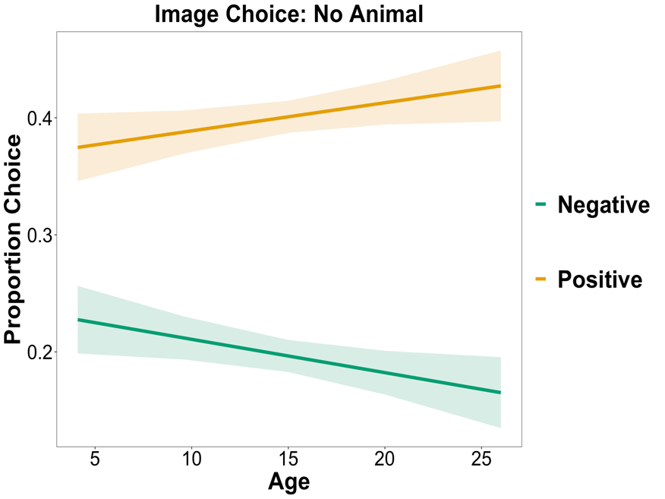
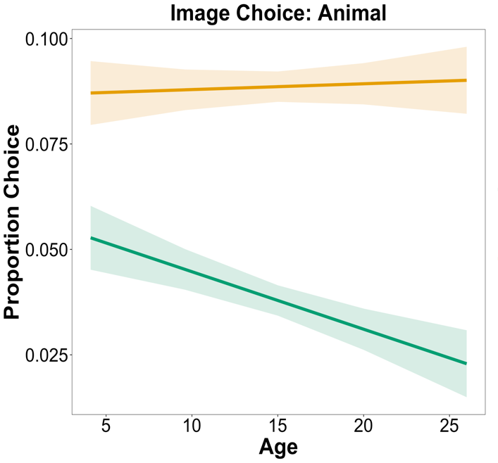
Figure S3. Proportion of trials that positive (gold) and negative (green) images were chosen across age in stimuli with animals (left) and stimuli without animals (right). Proportions reflect overall choice of positive or negative images, collapsed across condition. Proportion choice is out of the total number of trials. Solid colored lines depict linear model fits. Shaded regions depict standard errors.

c. Descriptive Item-Level Analysis

As a supplementary descriptive analysis, we explored the frequency with which each item was chosen in the whole sample and in younger and older participants separately (see Table S2.
Table S2. Number of times images were chosen in whole sample.
IAPS Image Number | Description of Image | No. of Participants who Chose the Image (out of N=192)
9926 | Flood | 104
9622 | Jet | 100
1050 | Snake | 98
5973 | Tornado | 97
9341 | Pollution | 96
9600 | Boat | 96
9050 | Plane Crash | 92
9561 | Sick Kitty | 92
2683 | War | 90
6830 | Guns | 89
9560 | Duck in Oil | 87
9120 | Oil Fires | 86
6010 | Jail | 83
9900 | Car Accident | 83
9530 | Boys | 82
1300 | Pit Bull | 81
9041 | Scared Child | 81
7359 | Pie w/ Bug | 79
9480 | Skull | 79
9470 | Ruins | 78
6312 | Abduction | 74
9001 | Cemetery | 70
6836 | Police | 69
9471 | Burning Bldg | 69
9911 | Car Accident | 67
1220 | Spider | 62
9220 | Cemetery | 60
2095 | Toddler | 56
9421 | Soldier | 56
9340 | Garbage | 55
2750 | Bum | 52
1280 | Rat | 50
2900 | Crying Boy | 49
3230 | Dying Man | 46
9373 | Garbage | 44
9584 | Dental Exam | 44
7380 | Roach on Pizza | 43
9290 | Garbage | 42
9300 | Dirty | 35
3160 | Eye Disease | 32

To further explore negative item choice frequencies, we split the sample into younger participants (ages 12 or younger) and older participants (ages 13 or older; see Table S3).
Table S3. Number of times images were chosen in younger and older participants.

Children (< 13 years) |  |  | Adolescents and Young Adults (>= 13 years)
IAPS Image Number | Description of Image | No. of Participants who Chose the Image (out of N=80) | IAPS Image Number | Description of Image | No. of Participants who Chose the Image (out of N=112)
9561 | Sick Kitty | 57 | 2683 | War | 57
1050 | Snake | 50 | 9926 | Flood | 57
9600 | Boat | 49 | 5973 | Tornado | 55
9926 | Flood | 47 | 9622 | Jet | 55
9560 | Duck in Oil | 45 | 9341 | Pollution | 54
9622 | Jet | 45 | 6830 | Guns | 52
7359 | Pie w/ Bug | 44 | 9120 | Oil Fires | 51
9050 | Plane Crash | 43 | 9050 | Plane Crash | 49
5973 | Tornado | 42 | 1050 | Snake | 48
9041 | Scared Child | 42 | 6836 | Police | 48
9341 | Pollution | 42 | 9900 | Car Accident | 48
6010 | Jail | 40 | 9600 | Boat | 47
1300 | Pit Bull | 39 | 9530 | Boys | 46
6830 | Guns | 37 | 9480 | Skull | 45
9530 | Boys | 36 | 6010 | Jail | 43
9120 | Oil Fires | 35 | 9470 | Ruins | 43
9470 | Ruins | 35 | 1300 | Pit Bull | 42
9900 | Car Accident | 35 | 6312 | Abduction | 42
9480 | Skull | 34 | 9560 | Duck in Oil | 42
1220 | Spider | 33 | 9001 | Cemetery | 40
2683 | War | 33 | 9471 | Burning Bldg | 40
1280 | Rat | 32 | 9041 | Scared Child | 39
2095 | Toddler | 32 | 7359 | Pie w/ Bug | 35
6312 | Abduction | 32 | 9561 | Sick Kitty | 35
9911 | Car Accident | 32 | 9911 | Car Accident | 35
2900 | Crying Boy | 30 | 9340 | Garbage | 34
9001 | Cemetery | 30 | 2750 | Bum | 32
9220 | Cemetery | 29 | 9421 | Soldier | 32
9471 | Burning Bldg | 29 | 9220 | Cemetery | 31
7380 | Roach on Pizza | 28 | 1220 | Spider | 29
9300 | Dirty | 27 | 2095 | Toddler | 24
3230 | Dying Man | 24 | 9290 | Garbage | 23
9421 | Soldier | 24 | 3230 | Dying Man | 22
9584 | Dental Exam | 24 | 9373 | Garbage | 21
9373 | Garbage | 23 | 9584 | Dental Exam | 20
6836 | Police | 21 | 2900 | Crying Boy | 19
9340 | Garbage | 21 | 1280 | Rat | 18
2750 | Bum | 20 | 3160 | Eye Disease | 16
9290 | Garbage | 19 | 7380 | Roach on Pizza | 15
3160 | Eye Disease | 16 | 9300 | Dirty | 8

- Supplemental analysis of reaction time data
In addition to our primary measures of valence choice and viewing time, we conducted a supplemental analysis of the amount of time taken to choose an image (i.e. “choice reaction time”). While this measure did not directly relate to our aim to assess the tendency to engage with negative stimuli, we examined these data as a secondary analysis to gather a complete picture of age-related changes in the affective choice task. For this analysis, we expected that children would overall take longer to make a choice, as it is well-established in the literature that children exhibit longer reaction times in a wide variety of tasks (e.g. Kosslyn et al., 1990).
We found that as expected, there was a main effect of age (F(1, 373) = 82.01, p < .001), such that time to make a choice decreased with increasing age. There was also a main effect of valence (F(2, 373) = 28.67, p < .001), such that participants were quickest to choose positive images and slowest to choose negative images. However, an interaction between age and valence did not reach statistical significance (F(2, 373) = 2.40, p = .09). This suggests that while there were baseline age differences in deliberation time, it was expressed similarly across all conditions, mitigating concern that difficulty or indecision had a stronger impact on the data at any particular age.
References
LoBue, V., & Rakison, D. H. (2013). What we fear most: A developmental advantage for threat-relevant stimuli. Developmental Review, 33(4), 285–303. https://doi.org/10.1016/j.dr.2013.07.005
LoBue, V., Rakison, D. H., & DeLoache, J. S. (2010). Threat perception across the life span: Evidence for multiple converging pathways.
Current Directions in Psychological Science, 19(6), 375–379. https://doi.org/10.1177/09637 21410 388801

