https://doi.org/10.1016/j.neuroimage.2014.10.005

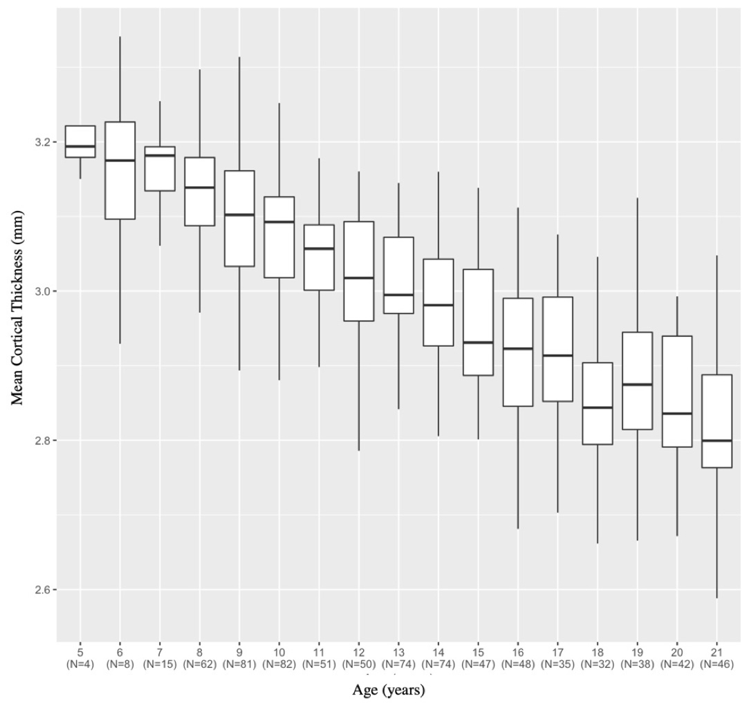
Supplementary Figure 1. Boxplot of mean cortical thickness by age bins. Top and bottom of boxes represent the first and third quartiles, respectively. Line each box’s center represents the median. “Whiskers” (i.e., lines permeating from the top and bottom of the box) represent the maximum and minimum values for that age bin. N, number of observations per age bin.

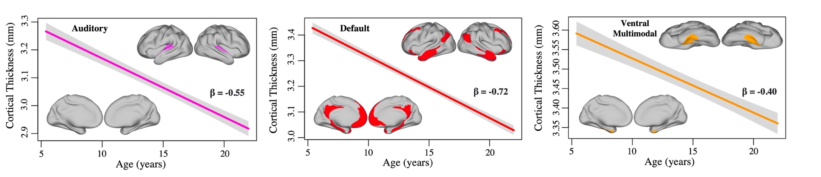
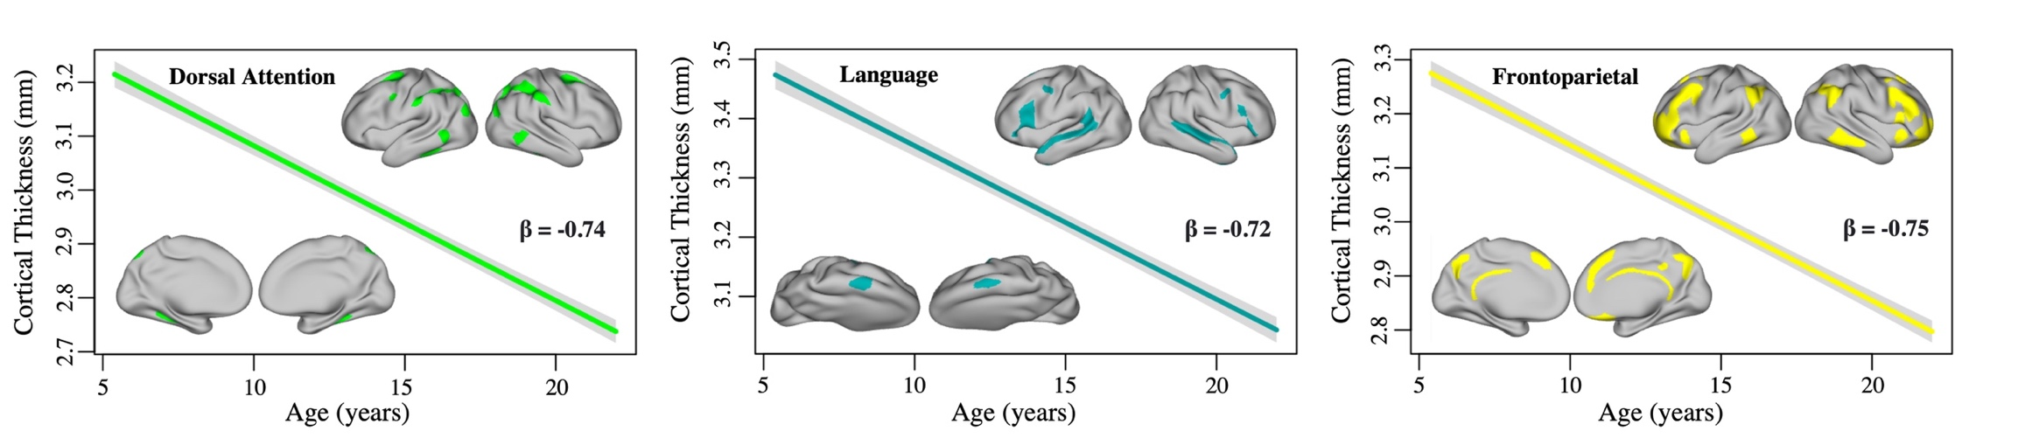
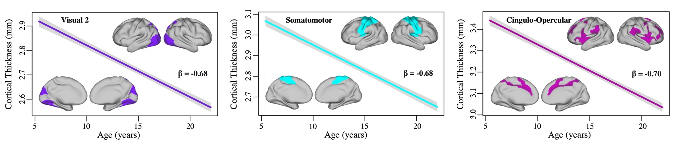

Supplementary Figure 2. Linear trajectories of network cortical thickness. β, standardized beta.

Meng Test Correlated Correlation Coefficients

 | 1 | 2 | 3 | 4 | 5 | 6 | 7 | 8 | 9 | r_{age}
1. Visual 2 | — |  |  |  |  |  |  |  |  | -0.46
2. Somatomotor | 0.23 | — |  |  |  |  |  |  |  | -0.46
3. Cingulo-Opercular | -0.32 | -0.76 | — |  |  |  |  |  |  | -0.45
4. Dorsal Attention | 3.51*** | 3.03** | 3.16*** | — |  |  |  |  |  | -0.50
5. Language | -0.25 | -0.53 | 0.08 | -3.00** | — |  |  |  |  | -0.45
6. Frontoparietal | 1.71* | 1.88* | 3.18*** | -0.88 | 2.51** | — |  |  |  | -0.49
7. Auditory | -4.87*** | -5.36*** | -4.77*** | -6.65*** | -5.01*** | -5.91*** | — |  |  | -0.34
8. Default | 1.49 | 1.47 | 2.55** | -1.03 | 2.11* | -0.34 | 5.78*** | — |  | -0.48
9. Ventral Multimodal | -6.21*** | -6.02*** | -5.85*** | -7.65*** | -5.80*** | -7.09*** | -1.88* | -7.36*** | — | -0.27
Supplementary Table 1. Z-score values from Meng test conducted to identify significant differences between each network’s correlated
correlation coefficients. r, Pearson correlation coefficient of network average cortical thickness with age; *, p < 0.05; **, p < 0.01; ***,
p < 0.001.

VIS 1 |  | VIS 2 |  | SOM |  | CON |  | DAN |  | LAN |  | FPN |  | AUD |  | DMN |  | PMM |  | VMM |  | ORA
L | R | L | R | L | R | L | R | L | R | L | R | L | R | L | R | L | R | L | R | L | R | L | R
-.09 | -.24 | -.27 | -.36 | -.23 | -.31 | -.27 | -.30 | -.51 | -.54 | -.28 | -.29 | -.21 | -.23 | -.28 | -.28 | -.42 | -.47 | -.47 | -.49 | -.10 | -.15 | .15 | .09
-.37 | -.39 | -.43 | -.51 | -.44 | -.42 | -.50 | -.58 | -.52 | -.58 | -.37 | -.38 | -.49 | -.56 | -.29 | -.26 | -.46 | -.50 | -.39 | -.38 | -.37 | -.38 | .13 | .17
-.45 | -.53 | -.35 | -.46 | -.46 | -.51 | -.44 | -.55 | -.46 | -.50 | -.49 | -.45 | -.41 | -.47 | -.11 | -.14 | -.29 | -.39 | -.39 | -.37 |  |  | .26 | .17
 |  | -.40 | -.46 | -.55 | -.58 | -.31 | -.35 | -.42 | -.45 | -.32 | -.37 | -.42 | -.44 | -.32 | -.36 | -.31 | -.41 |  | -.42
 |  | -.43 | -.50 | -.38 | -.42 | -.44 | -.46 | -.48 | -.52 | -.26 | -.11 | -.38 | -.41 | -.26 | -.31 | -.31 | -.23
 |  | -.20 | -.36 | -.34 | -.41 | -.52 | -.55 | -.53 | -.60 | -.37 | -.49 | -.47 | -.47 | -.36 | -.33 | -.36 | -.41
 |  | -.44 | -.49 | -.56 | -.57 | -.12 | -.19 | -.26 | -.33 | -.45 | -.56 | -.23 | -.24 | -.31 | -.40 | -.20 | -.24
 |  | -.44 | -.47 | -.55 | -.63 | -.17 | -.17 | -.29 | -.30 | -.45 | -.49 | -.41 | -.46 |  |  | -.36 | -.43
 |  | -.51 | -.55 | -.53 | -.53 | -.32 | -.41 | -.38 | -.41 | -.10 | -.11 | -.42 | -.33 |  |  | -.40 | -.41
 |  | -.23 | -.21 | -.58 | -.60 | -.37 | -.35 | -.50 | -.52 |  |  | -.38 | -.35 |  |  | -.35 | -.40
 |  | -.37 | -.44 | -.34 | -.21 | -.46 | -.48 | -.53 | -.56 |  |  | -.43 | -.50 |  |  | -.41 | -.45
 |  | -.31 | -.36 | -.31 | -.32 | -.47 | -.47 |  |  |  |  | -.21 | -.37 |  |  | -.44 | -.50
 |  | -.29 | -.35 | -.39 | -.41 | -.34 | -.33 |  |  |  |  | -.38 | -.36 |  |  | -.49 | -.52
 |  | -.21 | -.26 | -.38 | -.36 | -.39 | -.47 |  |  |  |  | -.28 | -.38 |  |  | -.43 | -.48
 |  | -.33 | -.39 | -.35 | -.44 | -.05 | -.05 |  |  |  |  | -.32 | -.37 |  |  | -.45 | -.46
 |  | -.43 | -.52 | -.36 | -.32 | -.35 | -.38 |  |  |  |  | -.38 | -.44 |  |  | -.46 | -.49
 |  | -.50 | -.52 | -.37 | -.37 | -.35 | -.25 |  |  |  |  | -.54 | -.59 |  |  | -.37 | -.42
 |  | -.35 | -.33 | -.40 | -.39 | -.25 | -.31 |  |  |  |  | -.52 | -.59 |  |  | -.46 | -.48
 |  | -.36 | -.41 | -.28 | -.43 | -.36 | -.41 |  |  |  |  | -.54 | -.58 |  |  | -.40 | -.46
 |  | -.19 | -.30 |  |  | -.46 | -.47 |  |  |  |  | -.36 | -.44 |  |  | -.35 | -.37
 |  | -.27 | -.36 |  |  | -.53 | -.55 |  |  |  |  | -.45 | -.43 |  |  | -.15 | -.16
 |  | -.35 | -.33 |  |  | -.16 | -.11 |  |  |  |  |  |  |  |  | -.05 | -.09
 |  | -.41 | -.36 |  |  | -.42 | -.40 |  |  |  |  |  |  |  |  | -.03 | -.18
 |  | -.36 | -.42 |  |  | -.20 | -.23 |  |  |  |  |  |  |  |  | -.14 | -.25
 |  | -.31 | -.35 |  |  | -.38 | -.44 |  |  |  |  |  |  |  |  | .01 | -.07
 |  | -.35 | -.46 |  |  | -.18 | -.23 |  |  |  |  |  |  |  |  | -.55 | -.53
 |  | -.22 | -.32 |  |  |  |  |  |  |  |  |  |  |  |  | -.19 | -.10
 |  |  |  |  |  |  |  |  |  |  |  |  |  |  |  | -.36 | -.43
 |  |  |  |  |  |  |  |  |  |  |  |  |  |  |  | -.24 | -.40
 |  |  |  |  |  |  |  |  |  |  |  |  |  |  |  | -.48 | -.53
 |  |  |  |  |  |  |  |  |  |  |  |  |  |  |  | -.51 | -.53
 |  |  |  |  |  |  |  |  |  |  |  |  |  |  |  | -.14 | -.20
 |  |  |  |  |  |  |  |  |  |  |  |  |  |  |  | -.47 | -.46
 |  |  |  |  |  |  |  |  |  |  |  |  |  |  |  | .23 | .04
 |  |  |  |  |  |  |  |  |  |  |  |  |  |  |  | -.21 | -.35
 |  |  |  |  |  |  |  |  |  |  |  |  |  |  |  | -.49 | -.46
Supplementary Table 2. Standardized beta values of homologous areas for each network by left and right hemisphere.

 | AIC
Network | Age + Sex | Age*Sex | Age + PDS | Age*PDS | Age + ME | Age*ME | Age + INR | Age*INR
Mean | -1506.79 | -1504.80 | -1525.08 | -1523.10 | -1515.90 | -1518.32 | -1360.49 | -1358.90
Visual 1 | -1400.47 | -1397.13 | -1398.68 | -1396.99 | -1401.60 | -1400.92 | -1257.35 | -1255.84
Visual 2 | -1500.21 | -1496.80 | -1508.68 | -1508.36 | -1500.83 | -1504.50 | -1347.58 | -1345.58
Somatomotor | -1213.17 | -1211.22 | -1218.02 | -1216.52 | -1215.89 | -1212.58 | -1110.81 | -1108.94
Cingulo-Opercular | -1365.20 | -1363.22 | -1368.95 | -1367.03 | -1371.52 | -1371.68 | -1244.37 | -1243.25
Dorsal Attention | -1287.08 | -1285.34 | -1296.15 | -1294.83 | -1287.23 | -1291.19 | -1168.38 | -1166.55
Language | -1292.25 | -1290.62 | -1294.64 | -1292.94 | -1292.68 | -1293.77 | -1158.50 | -1156.87
Frontoparietal | -1363.72 | -1362.98 | -1378.62 | -1376.62 | -1363.87 | -1361.50 | -1225.94 | -1224.63
Auditory | -920.96 | -918.96 | -920.10 | -918.10 | -920.92 | -919.74 | -809.08 | -807.10
Default | -1490.87 | -1490.06 | -1495.50 | -1493.67 | -1499.48 | -1495.63 | -1337.79 | -1335.60
Posterior Multimodal | -1038.96 | -1038.71 | -1057.29 | -1055.46 | -1040.66 | -1033.21 | -948.67 | -946.99
Ventral Multimodal | -917.58 | -915.74 | -918.26 | -917.64 | -930.74 | -923.47 | -831.98 | -831.38
Orbit-Affective | -192.96 | -191.61 | -193.15 | -192.79 | -188.35 | -182.64 | -167.72 | 165.75
Supplementary Table 3. AIC values assessing model fit between simple models (i.e., no interaction term) and complex models (i.e., interaction term) for each network for sex, PDS, ME, and INR. Bolded values indicate best model fit. AIC, Akaike information criteria; PDS, pubertal development scale; ME, maternal education; INR, income-to-needs ratio.
Network & Variables | B | 95% CI | β | t | q
Mean CT
Intercept | 3.28 | [3.16, 3.39] |  | 54.54 | .000
Sex | 0.00 | [-0.01, 0.02] | 0.02 | 0.62 | .795
Visual 1
Intercept | 2.46 | [2.33, 2.59] |  | 37.87 | .000
Sex | -0.01 | [-0.03, 0.00] | -0.05 | -1.60 | .267
Visual 2
Intercept | 3.03 | [2.99, 3.07] |  | 149.06 | .000
Sex | 0.00 | [-0.01, 0.01] | 0.00 | 0.16 | .950
Somatomotor
Intercept | 3.16 | [3.01, 3.30] |  | 43.68 | .000
Sex | 0.01 | [-0.00, 0.03] | 0.05 | 1.85 | .242
Cingulo-Opercular
Intercept | 3.57 | [3.44, 3.70] |  | 54.50 | .000
Sex | 0.00 | [-0.01, 0.02] | 0.01 | 0.53 | .795
Dorsal Attention
Intercept | 3.34 | [3.20, 3.48] |  | 48.52 | .000
Sex | 0.00 | [-0.01, 0.02] | 0.00 | 0.08 | .977
Language
Intercept | 3.66 | [3.53, 3.80] |  | 53.87 | .000
Sex | -0.00 | [-0.02, 0.01] | 0.00 | -0.03 | .950
Frontoparietal
Intercept | 3.37 | [3.24, 3.50] |  | 51.47 | .000
Sex | 0.01 | [-0.00, 0.03] | 0.04 | 1.75 | .242
Auditory
Intercept | 3.49 | [3.23, 3.66] |  | 40.26 | .000
Sex | 0.01 | [-0.01, 0.03] | 0.02 | 0.77 | .762
Default
Intercept | 3.50 | [3.39, 3.62] |  | 58.10 | .000
Sex | 0.00 | [-0.01, 0.01] | 0.01 | 0.25 | .950
Posterior Multimodal
Intercept | 3.30 | [3.14, 3.46] |  | 40.87 | .000
Sex | 0.01 | [-0.01, 0.03] | 0.02 | 0.85 | .762
Ventral Multimodal
Intercept | 3.72 | [3.55, 3.90] |  | 42.79 | .000
Sex | 0.02 | [0.00, 0.04] | 0.07 | 2.03 | .242
Orbito-Affective
Intercept | 3.42 | [3.15, 3.69] |  | 24.70 | .000
Sex | 0.03 | [-0.06, 0.00] | -0.07 | -2.01 | .242
Supplementary Table 4. Multiple regression statistics for main effect of sex on cortical thickness for each network. q, FDR-corrected p-value for 13 comparisons.

Network | Female | Male | Mean Differences |  | Variance Ratio
 | M | M | q | d | VR | q
Visual 1 | -0.004 | 0.003 | n.s. | 0.06 | -0.06 | n.s.
Visual 2 | -0.009 | 0.009 | n.s. | 0.12 | 0.01 | n.s.
Somatomotor | 0.001 | -0.001 | n.s. | 0.01 | -0.13 | n.s.
Cingulo-Opercular | -0.001 | 0.002 | n.s. | 0.01 | -0.10 | n.s.
Dorsal Attention | 0.001 | -0.001 | n.s. | 0.01 | -0.18 | n.s.
Language | 0.004 | -0.003 | n.s. | 0.04 | -0.00 | n.s.
Frontoparietal | -0.005 | 0.009 | n.s. | 0.07 | -0.16 | n.s.
Auditory | -0.002 | 0.004 | n.s. | 0.03 | -0.24 | n.s.
Default | -0.005 | 0.007 | n.s. | 0.08 | -0.16 | n.s.
Posterior Multimodal | -0.005 | 0.004 | n.s. | 0.05 | 0.04 | n.s.
Ventral Multimodal | 0.001 | -0.001 | n.s. | 0.01 | 0.15 | n.s.
Orbito-Affective | -0.007 | 0.008 | n.s. | 0.06 | -0.03 | n.s.
Supplementary Table 5. Mean differences and Fisher’s variable ratio of CT variability by sex. M, mean; d, Cohen’s d; VR, variance ratio; q, FDR-corrected p-value for multiple comparisons expressed as significant or non-significant.

Network & Variables | B | 95% CI | β | t | q
Mean CT
Intercept | 3.27 | [3.15, 3.39] |  | 55.11 | .000
PDS | -0.03 | [-0.04, -0.02] | -0.21 | -11.25 | .000
Visual 1
Intercept | 2.46 | [2.33, 2.58] |  | 37.83 | .000
PDS | -0.01 | [-0.02, 0.00] | -0.09 | -1.45 | .166
Visual 2
Intercept | 3.00 | [2.88, 3.11] |  | 50.22 | .000
PDS | -0.02 | [-0.04, -0.01] | -0.18 | 1.43 | .002
Somatomotor
Intercept | 3.15 | [3.01, 3.29] |  | 43.72 | .000
PDS | -0.02 | [-0.04, -0.01] | -0.14 | -2.61 | .020
Cingulo-Opercular
Intercept | 3.56 | [3.43, 3.70] |  | 54.53 | .000
PDS | -0.02 | [-0.03, -0.00] | -0.12 | -2.39 | .028
Dorsal Attention
Intercept | 3.33 | [3.20, 3.47] |  | 48.66 | .000
PDS | -0.03 | [-0.04, -0.01] | -0.16 | -3.32 | .002
Language
Intercept | 3.66 | [3.52, 3.79] |  | 53.86 | .000
PDS | -0.02 | [-0.03, 0.00] | -0.11 | -2.09 | .050
Frontoparietal
Intercept | 3.36 | [3.23, 3.49] |  | 51.75 | .000
PDS | -0.03 | [-0.04, -0.02] | -0.19 | -4.11 | .000
Auditory
Intercept | 3.49 | [3.23, 3.66] |  | 40.22 | .000
PDS | -0.01 | [-0.03, 0.01] | -0.06 | -1.06 | .289
Default
Intercept | 3.50 | [3.38, 3.62] |  | 58.24 | .000
PDS | -0.02 | [-0.03, -0.00] | -0.12 | -2.57 | .020
Posterior Multimodal
Intercept | 3.29 | [3.13, 3.11] |  | 41.23 | .000
PDS | -0.05 | [-0.06, -0.02] | -0.23 | -4.71 | .000
Ventral Multimodal
Intercept | 3.72 | [3.55, 3.89] |  | 42.78 | .000
PDS | -0.01 | [-0.03, 0.01] | -0.09 | -1.43 | .166
Orbito-Affective
Intercept | 3.55 | [3.15, 3.70] |  | 26.96 | .000
PDS | 0.03 | [0.00, 0.06] | 0.11 | 1.62 | .166
Supplementary Table 6. Multiple regression statistics for main effect of PDS on cortical thickness for each network. q, FDR-corrected p-value for 13 comparisons. PDS, pubertal development scores controlling for age.

Network & Variables | Sum Sq | df | F | q
Mean CT
Intercept | 23.16 | 1 | 2777.71 | .000
ME | 0.11 | 4 | 3.15 | .028
Age*ME | 0.09 | 4 | 2.57 | .037
Dorsal Attention
Intercept | 23.95 | 1 | 2186.56 | .000
ME | 0.11 | 4 | 2.58 | .036
Age*ME | 0.13 | 4 | 2.95 | .037
Network & Variables | Sum Sq | df | F | q
Visual 1
Intercept | 13.75 | 1 | 1408.48 | .000
ME | 0.07 | 4 | 1.92 | .126
Visual 2 |  | 1
Intercept | 20.72 | 4 | 2460.28 | .000
ME | 0.08 | 1 | 2.52 | .097
Somatomotor |  | 1
Intercept | 22.82 | 4 | 1885.94 | .000
ME | 0.13 | 1 | 2.66 | .096
Cingulo-Opercular |  | 4
Intercept | 28.59 | 1 | 2932.05 | .000
ME | 0.14 | 4 | 3.60 | .026
Language |  | 4
Intercept | 30.77 | 1 | 2861.74 | .000
ME | 0.09 | 4 | 2.09 | .126
Frontoparietal |  | 1
Intercept | 26.03 | 4 | 2618.28 | .000
ME | 0.08 | 1 | 2.02 | .126
Auditory |  | 4
Intercept | 27.83 | 1 | 1597.71 | .000
ME | 0.14 | 4 | 1.97 | .126
Default |  | 1
Intercept | 27.91 | 4 | 3351.20 | .000
ME | 0.14 | 1 | 4.13 | .015
Posterior Multimodal |  | 4
Intercept | 25.03 | 1 | 1636.02 | .000
ME | 0.02 | 4 | 0.29 | .886
Ventral Multimodal |  | 1
Intercept | 31.37 | 4 | 1084.31 | .000
ME | 0.37 | 1 | 5.28 | .004
Orbito-Affective |  | 1
Intercept | 26.90 | 4 | 590.84 | .000
ME | 0.08 | 1 | 0.42 | .868
Supplementary Table 7. Multiple regression statistics for main effect of maternal education and age by maternal education interaction on cortical thickness for each network. q, FDR-corrected p-value for 13 comparisons.
Network & Variables | B | 95% CI | β | t | q
Mean CT
Intercept | 3.24 | [3.12, 3.37] |  | 50.80 | .000
INR | 0.00 | [0.00, 0.01] | 0.05 | 2.01 | .127
Visual 1
Intercept | 2.47 | [2.34, 2.61] |  | 35.53 | .000
INR | 0.00 | [-0.00, 0.00] | 0.04 | 1.13 | .422
Visual 2
Intercept | 2.99 | [2.86, 3.12] |  | 45.42 | .000
INR | 0.00 | [0.00, 0.01] | 0.07 | 2.35 | .125
Somatomotor
Intercept | 3.13 | [2.97, 3.28] |  | 40.17 | .000
INR | 0.00 | [-0.00, 0.01] | 0.03 | 0.93 | .506
Cingulo-Opercular
Intercept | 3.55 | [3.41, 3.68] |  | 51.32 | .000
INR | 0.00 | [-0.00, 0.01] | 0.01 | 1.93 | .127
Dorsal Attention
Intercept | 3.33 | [3.19, 3.48] |  | 45.72 | .000
INR | 0.00 | [-0.00, 0.00] | 0.01 | 0.46 | .698
Language
Intercept | 3.64 | [3.50, 3.78] |  | 50.12 | .000
INR | 0.00 | [-0.00, 0.00] | 0.02 | 0.86 | .506
Frontoparietal
Intercept | 3.35 | [3.21, 3.48] |  | 47.86 | .000
INR | 0.00 | [-0.00, 0.00] | 0.02 | 0.67 | .594
Auditory
Intercept | 3.49 | [3.31, 3.68] |  | 37.26 | .000
INR | 0.00 | [-0.00, 0.01] | 0.04 | 1.27 | .382
Default
Intercept | 3.49 | [3.36, 3.61] |  | 54.15 | .000
INR | 0.00 | [-0.00, 0.01] | 0.05 | 1.90 | .127
Posterior Multimodal
Intercept | 3.25 | [3.08, 3.42] |  | 38.13 | .000
INR | 0.00 | [0.00, 0.01] | 0.06 | 2.18 | .127
Ventral Multimodal
Intercept | 3.73 | [3.55, 3.91] |  | 40.33 | .000
INR | 0.01 | [0.00, 0.01] | 0.11 | 3.03 | .033
Orbito-Affective
Intercept | 3.41 | [3.11, 3.70] |  | 22.90 | .000
INR | 0.00 | [-0.01, 0.01] | -0.01 | -0.23 | .815
Supplementary Table 8. Multiple regression statistics for main effect of INR on cortical thickness for each network. q, FDR-corrected p-value for 13 comparisons. INR, income-to-needs ratio.

